**Alisher Lenkhan, IT2-2011**



**Practice 1. Review**

1. The HR department needs a query to display all unique job codes from the EMPLOYEES table.

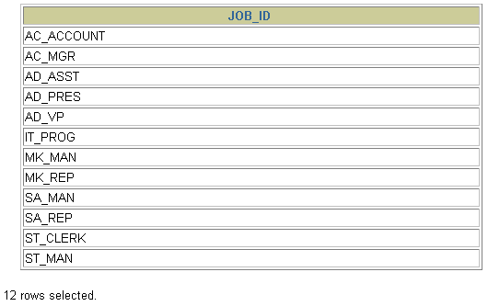

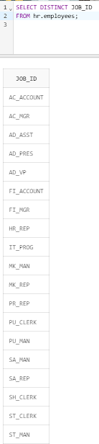

2. The HR department wants more descriptive column headings for its report on employees. Name the column headings Emp #, Employee, Job, and Hire Date, respectively.

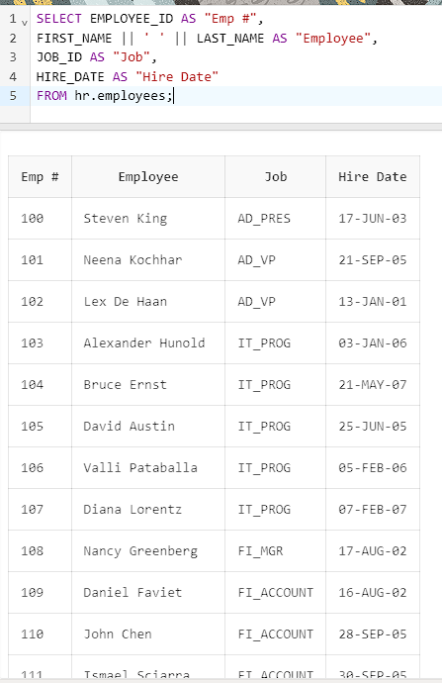

3. The HR department has requested a report of all employees and their job IDs. Display the last name concatenated with the job ID (separated by a comma and space) and name the column Employee and Title.

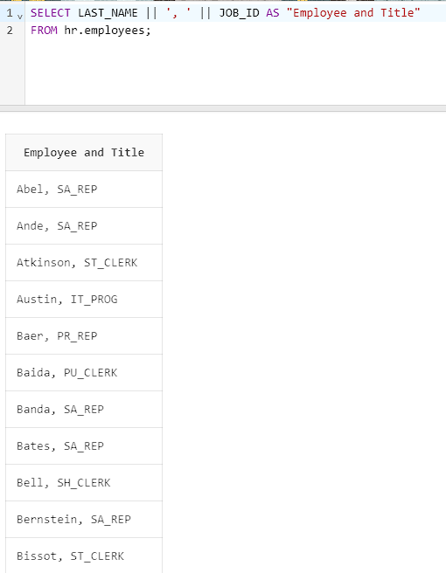

4. The HR department needs to find high-salary and low-salary employees. Create a report that displays the last name and salary for any employee whose salary is not in the range of $5,000 to $12,000.

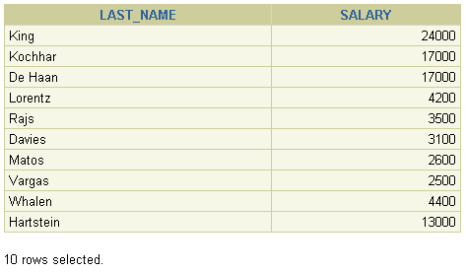

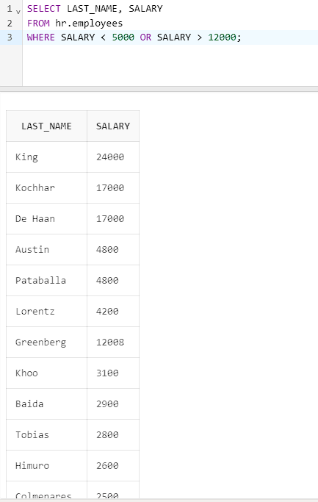

5. Create a report to display the last name, job ID, and start date for the employees with the last names of Matos and Taylor. Order the query in ascending order by start date.

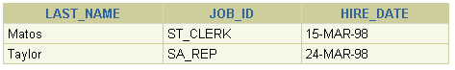

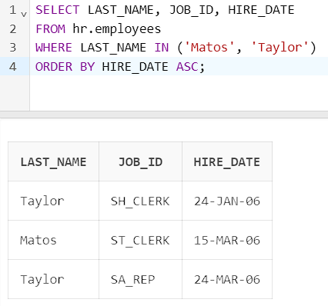

6. Display the last name and salary of employees who earn between $5,000 and $12,000 and are in department 20 or 50. Label the columns Employee and Monthly Salary, respectively.

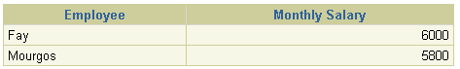

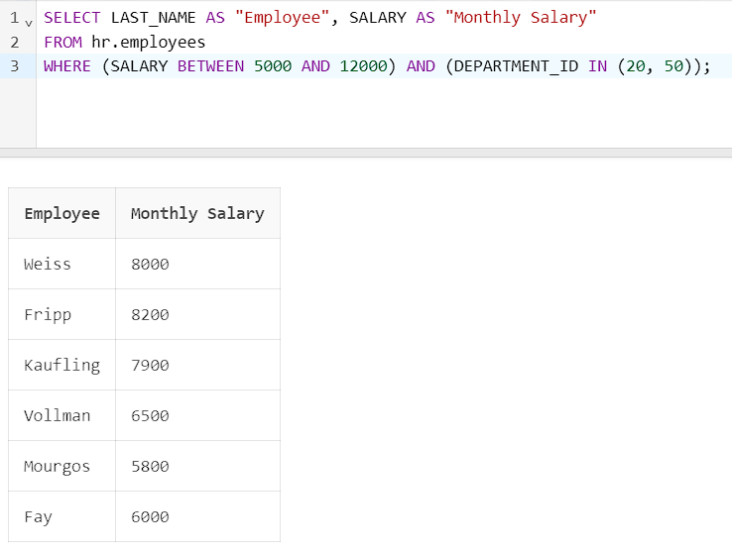

7. Display the last names of all employees who have both an *a* and an *e* in their last name.

5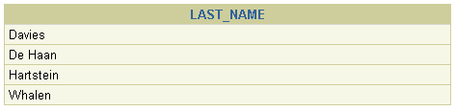

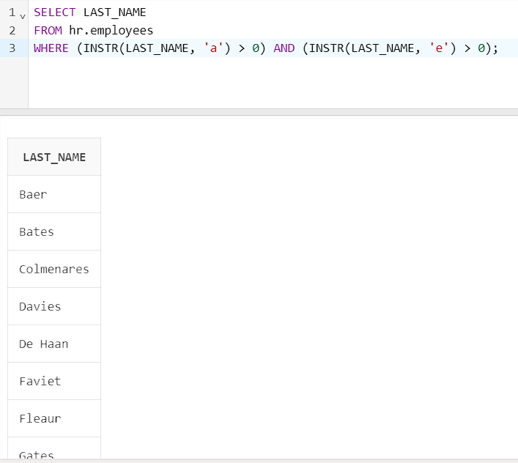

8. Display the last name, job, and salary for all employees whose jobs are either sales representative or stock clerk and whose salaries are not equal to $2,500, $3,500, or $7,000.

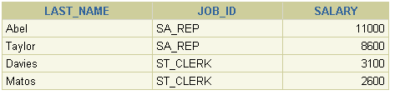

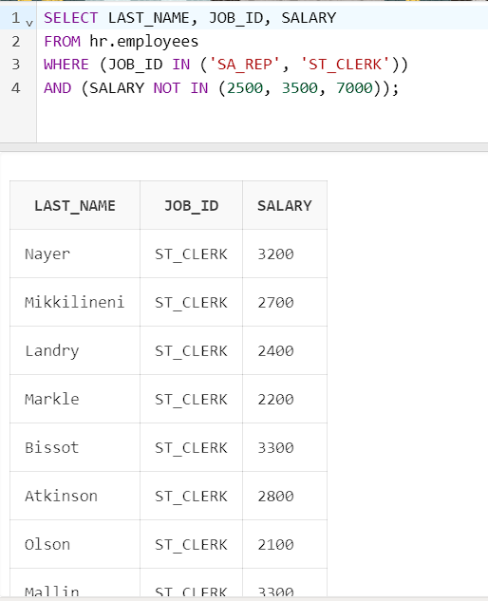

9. Write a query that displays the last name (with the first letter uppercase and all other letters lowercase) and the length of the last name for all employees whose name starts with the letters *J, A,* or *M*. Give each column an appropriate label. Sort the results by the employees’ last names.

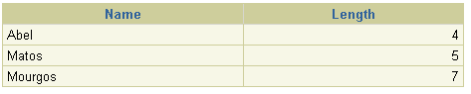

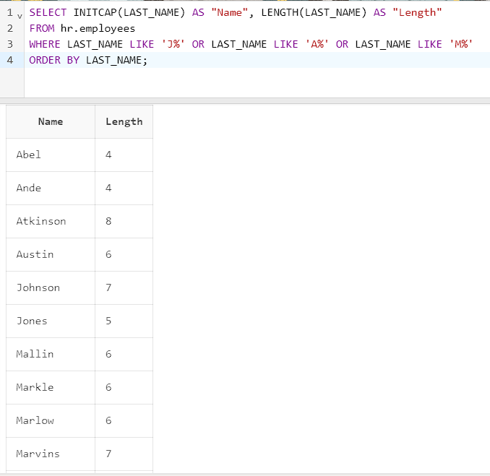

10. Create a report that produces the following for each employee:  
 <employee last name> earns <salary> monthly but wants <3 times salary>. Label the column Dream Salaries.

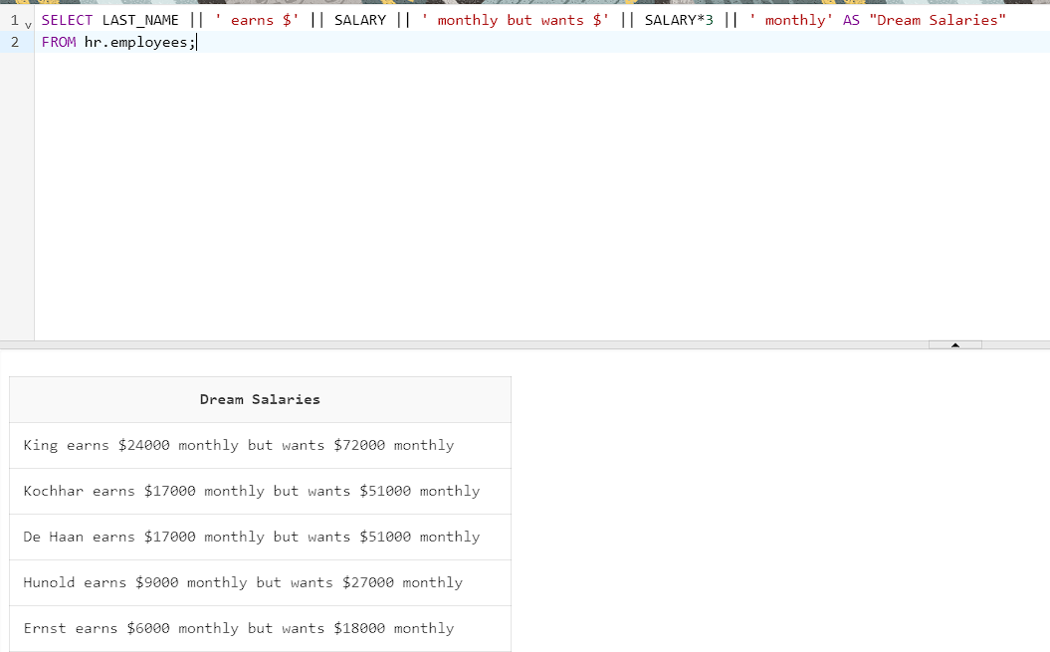

11. Display the last name, hire date, and day of the week on which the employee started. Label the column DAY. Order the results by the day of the week, starting with Monday.

SELECT LAST_NAME, HIRE_DATE, TO_CHAR(HIRE_DATE, 'Day') AS "DAY"

FROM hr.employees

ORDER BY

CASE TO_CHAR(HIRE_DATE, 'Day')

WHEN 'Monday' THEN 1

WHEN 'Tuesday' THEN 2

WHEN 'Wednesday' THEN 3

WHEN 'Thursday' THEN 4

WHEN 'Friday' THEN 5

WHEN 'Saturday' THEN 6

WHEN 'Sunday' THEN 7

END;

12. Display the minimum, maximum, sum, and average salary for each job type.

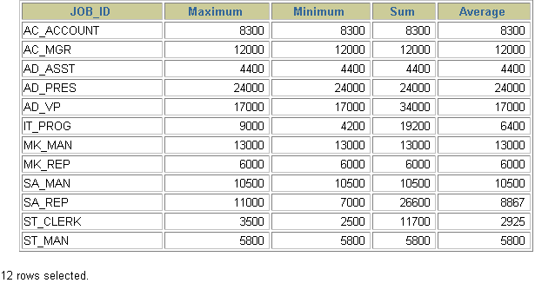

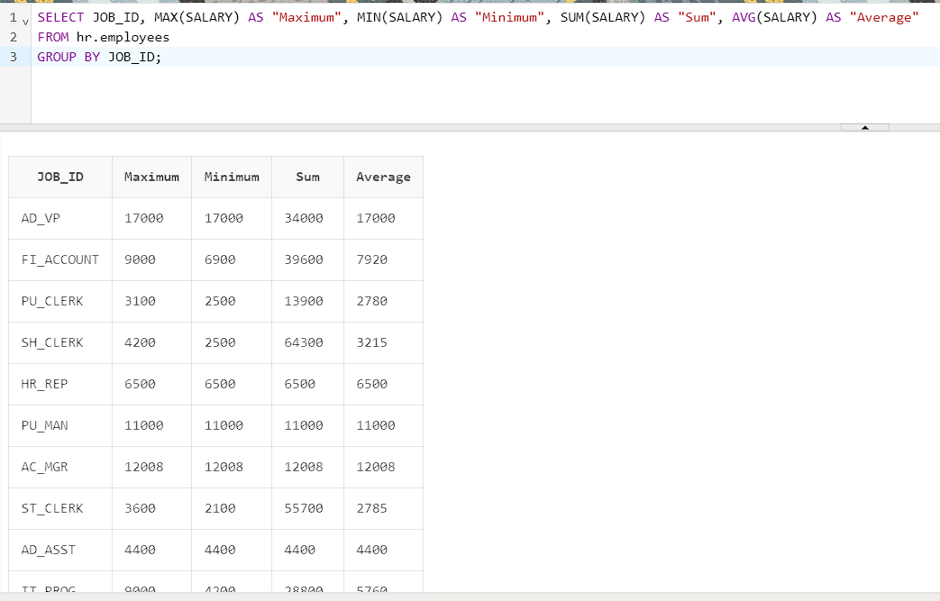

13. Create a report to display the manager number and the salary of the lowest-paid employee for that manager. Exclude anyone whose manager is not known. Exclude any groups where the minimum salary is $6,000 or less. Sort the output in descending order of salary.

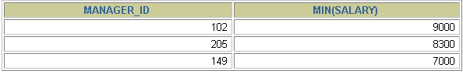

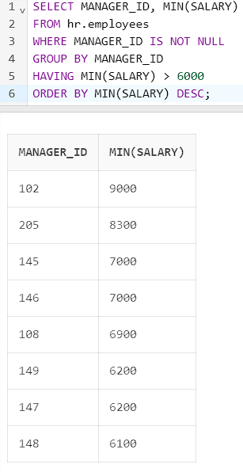

14. The HR department needs a report of all employees. Write a query to display the last name, department number, and department name for all employees.

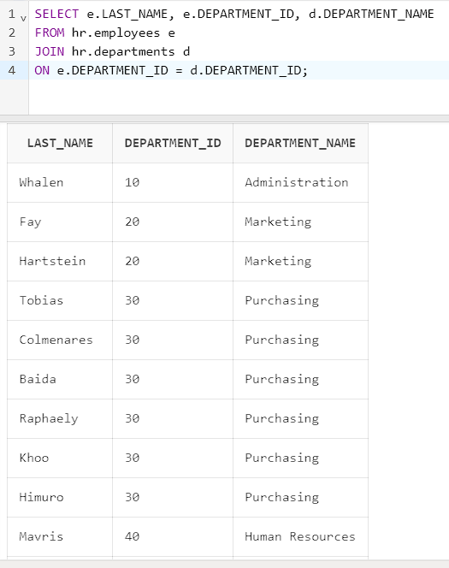

15. The HR department needs a report of employees in Toronto. Display the last name, job, department number, and department name for all employees who work in Toronto.

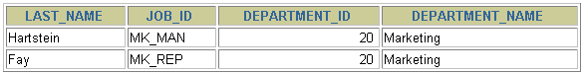

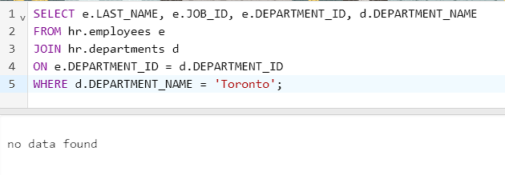

16. Create a report to display employees’ last name and employee number along with their manager’s last name and manager number. Label the columns Employee, Emp#, Manager, and Mgr#, respectively.

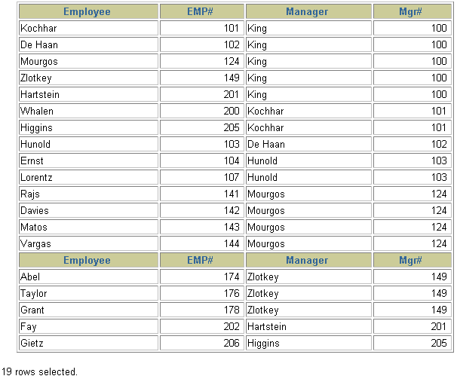

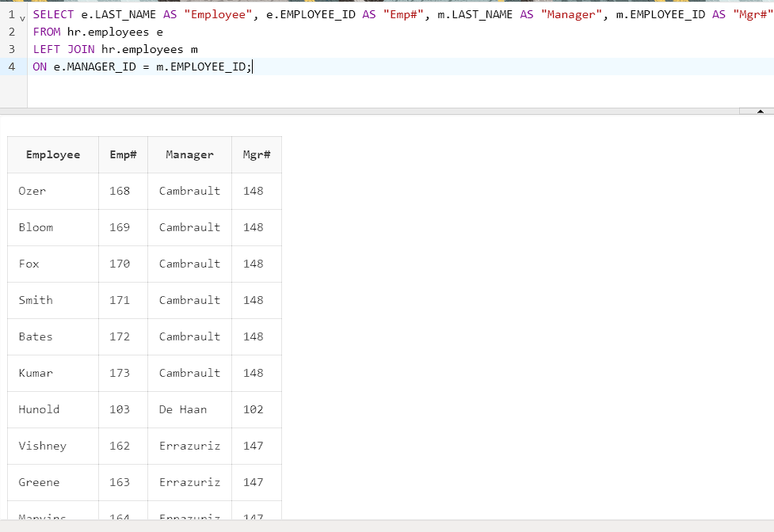

17. The HR department needs a query that prompts the user for an employee last name. The query then displays the last name and hire date of any employee in the same department as the employee whose name they supply (excluding that employee). For example, if the user enters Zlotkey, find all employees who work with Zlotkey (excluding Zlotkey).

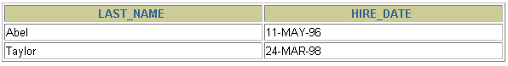

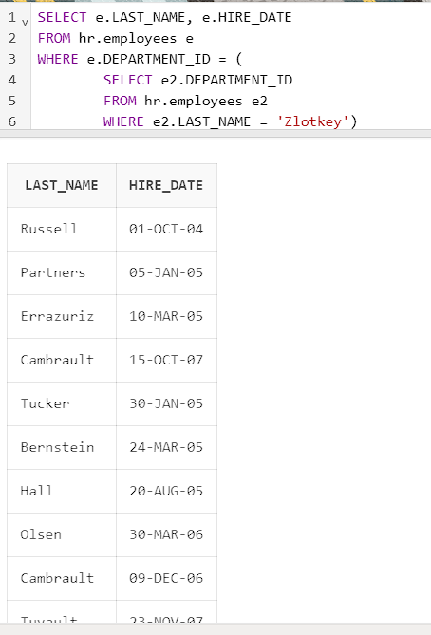

18. Create a report that displays the employee number, last name, and salary of all employees who earn more than the average salary. Sort the results in order of ascending salary.

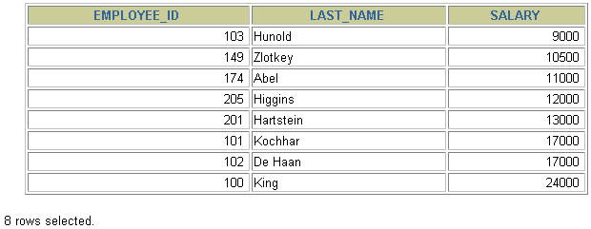

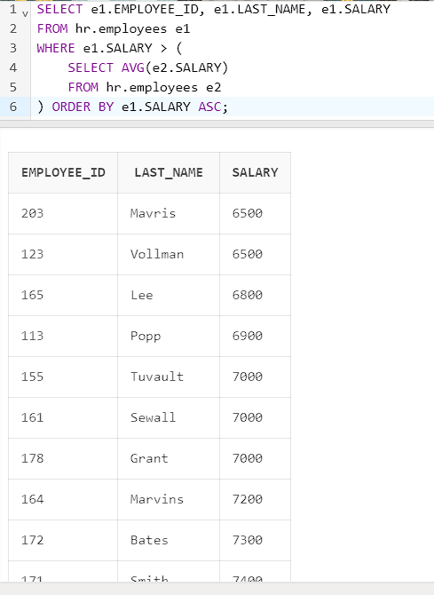

3